Assignment_1: Swager api link enhancement
Ask: Act as a senior architect and understand the entire project to do some enhancements
Plan: I want to enhance the application to accept swagger link as a input . [Strictly follow]- I should have 2 radio buttons on the top of the page under the Upload Swagger specification 1.Link 2.File upload
If i select on the link radio button then a new text field should appear to paste the link or enter the link and proceed with the rest of the functionalities
Application should validate the link and if the link format is fine then generate the test cases should be visisble for the user to go through the rest of the functions
when clciking the file upload radio button the default placeholder which is present now to upload files should appear and the user should able to upload files and continue rest of the functionalities
[Strict] whithout selecting an button it should not show any functionality Example : It is showing drop your Swagger file here as a default functionality when the application is getting loaded
[STRICT]The rest of the functionalities to geneerate the test cases from the swagger link also same as Generating test cases through the file upload
Do not break the existing implementation to generate test cases using the yaml/json file for swagger
Analyse the impacted files and plan and come with the plan for this enhancement .
After i review and Approve then implement in agent mode
Agent: Implement the enhancement
Output:
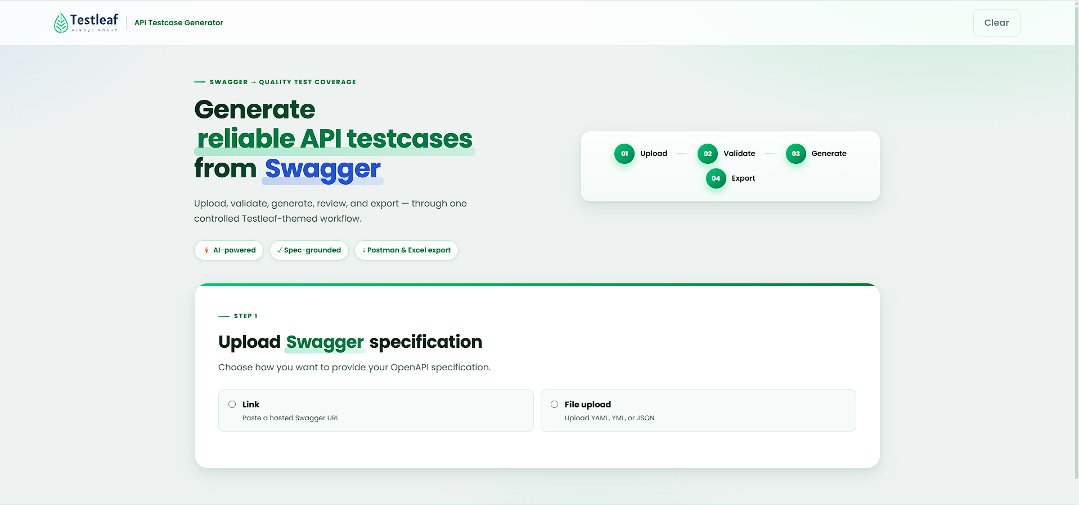

Assignment_2:
Enhance the existing application by implementing a feature that automatically categorizes the generated test cases into standard testing types such as Smoke, Sanity, Regression, Functional.
Once the test cases are generated, the application should classify each test case into the most appropriate category and display the categorized results in a structured and user-friendly format
The new functionality should seamlessly integrate with the existing test case generation workflow without impacting current features
Output:
